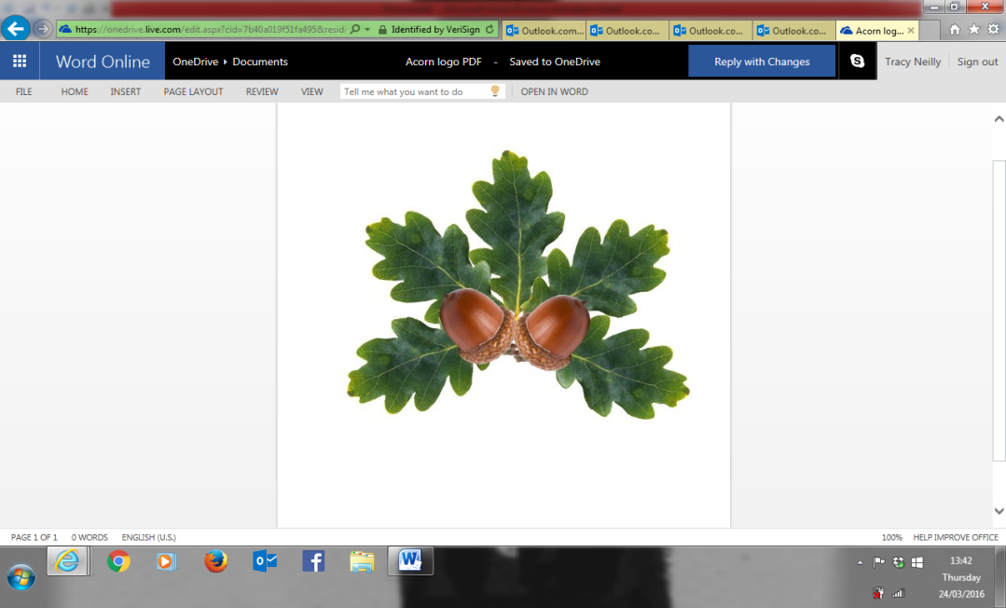

**Little Acorns Pre-School Folkestone**

**Grounds of**

**Folkestone Baptist Church**

**Hill Road**

**Folkestone**

**Kent**

**CT19 6LY**

**Manager Mrs T. Neilly**

**Tel: 01303 245562**

**Ofsted No: 127323 Mobile: 07879202160**

**Registered Charity No: 1088575 E-mail:littleacorns13@hotmail.co.uk**

**January 2020**

Hello everybody and welcome to term three and a new decade! We are very happy to see you all and have already had lots of fun this term. We are all reading We’re Going on a Bear Hunt this term and learning about things surrounding this book. If you know the story, ask your child about it! They’re very good at acting like bears!

**Term Dates:**

Term Three-

6th Jan-14th Feb

Term Four-

24th Feb- 1st April

Term Five-

20th April-22nd May

Term Six-

1st June-22nd July

*Please note that term four last day has changed!*

**Absences:**

We know that pre-school is not mandatory, but if your child is not going to be attending school, please contact us. We still have to keep up to date with KCC especially if you are accessing the universal 15 hours, 30 hours or free for two schemes. You can either Facebook us, message through the website or phone the setting or Tracy directly. Thank you

**Healthy Lunches:**

Please no chocolate bars, sweets or chocolates in lunchboxes. We try to promote healthy eating at pre-school so would prefer for lunches to be nice and healthy.

**Spaces Available:**

We still have a few spaces for 2, 3 and 4 year olds if you know anyone who may be interested, please tell them about us! We are filling up quickly and don’t want anyone to miss out.

If you think you may be entitled to 30 free hours childcare for the summer term (Term five and six) ask Tracy for some more information or google 30 hours eligibility. 30 hours is the same as having free childcare for the whole week, Monday-Friday, so it is worth looking into.

We do also have some spaces for our breakfast club. This runs every morning from 8:15 and costs only £5 per day. If you are interested, please ask Tracy in the office.

**The Hallway:**

We know that home time is very busy and the hallway gets extremely crowded, extremely quickly. To help this, there is a system in place which is parents to form a line by the gate and wait for the staff to call the child’s name. Please do not walk past other parents who are in the line as you will be made to wait. Also, we have a lot of prams in the hallway at the moment so please be mindful of others around you, and if you can possible leave the pram by the door to stop the congestion it would be helpful. There is also a policy where we do not open the door between 3.15-3.30 because it upsets the children too much. If you are collecting early, please do it before 3:15.

**Parking:**

Again, the car park does get very busy, so please be mindful of others around you and use the bays available. Parking in front of the gate is not safe so please refrain from doing this. The safety of the children is incredibly important and we will be doing everything to ensure everyone is safe.

**Spare Clothes/nappies:**

Please bring spare clothes for your child in a named bag as they can get wet/dirty/cold. Also, if your child is in nappies, please provide enough nappies, wipes, cream etc for the time they are here. Also, if your child has slippers or uniform please put names in them so we know whos are whose, as we get confused.

**Woods:**

We have been loving the woods over the past few terms and now we are beginning to see some lovely things growing in our allotments. If you have any winter bulbs you are not using, we would love to plant them with the children here